Barkatullah University, Bhopal

As per model syllabus of U.G.C. New Delhi



Faculty of Science
(approve by Computer Science BOS)

Syllabus & Prescribed Books

B.C.A. Semester Examination
2013 - 14
VI Semester
(10+2+3)
Barkatullah university, bhopal
SIXTH Semester

1. Course Code : 6. Maximum marks: 700
2. Course Name : BCA 7. Minimum Passing percentage : 33
3. Total Subject : 5 8. Project/Internship :Y
4. Compulsory Subject : 5 9. Project/Internship Passing : 33
5. Optional Subject : N

Sub. code | Subject Name | Theory |  |  |  |  |  |  | Practical |  | Total
Sub. code | Subject Name | Paper |  |  | CCE |  | Total Marks
 |  | 1 | Max. | Min. | Max. | Min. | Max. | Min. | Max. | Min. | Max. | Min.
Compulsory
69 | Foundation Course
 | 1. English Language and aspects of Development | 85 | 85 | 28 | 15 | 05 | 100 | 33 | 0 | 0 | 150 | 50
 | 2- cSfld vkWQ dEI;wVj rFkk bUQksjes’ku VsDukykWth&II | 25 | 25 | 08 | 10 | 04 | 40 | 33 | 15 | 5 | 150 | 50
 | Internet Technology & Security | 85 | 85 | 28 | 15 | 05 | 85 | 28 | 0 | 0 | 100 | 33
 | Software Engineering | 85 | 85 | 28 | 15 | 05 | 85 | 28 | 0 | 0 | 100 | 33
 | .Net Technology | 85 | 85 | 28 | 15 | 05 | 85 | 28 | 0 | 0 | 100 | 33
 | Java | 85 | 85 | 28 | 15 | 05 | 85 | 28 | 0 | 0 | 100 | 33
 | Practical Java & .Net | 0 | 0 | 0 | 0 | 0 | 0 | 0 | 50 | 17 | 50 | 17
 | Internship/Project (External Assessment) | 0 | 0 | 0 | 0 | 0 | 0 | 0 | 0 | 0 | 100 | 33

Department of Higher Education, Govt. of M.P.
Semester wise syllabus for under Graduates
As recommended by Central board of studies and
Approved by HE the Governor of M.P.
Session 2013-14

Class - B.A./B.Sc./B.Com/B.Sc. (Home Sci.)/
B.A. (Mgt.) BCA
Subject - Foundation Course
Paper Name - English Language and Aspects of Development
Paper - I
Semester - VI
Max. Marks : 85

particulars

Unit-I
1. William Wordsworth : “The World is Too Much With Us”
2. K. Aludiapillai : “Communication Education and Information Technology”
3. “Democratic Decentralisation”
4. S. C. Dubey : “Basic Quality of Life”
5. Sister Nivedita : “The Judgment Seat of Vikramaditya”
6. Juliun Huxley : “War as a Biological Phenomenon”
7. Robert Frost : “Stopping by Woods on a Snowy Evening”
8. Ruskin Bond : “The Cherry Tree”

Unit-II Short Essay of about 250-300 words.
Unit-III Translation of a short passage from Hindi to English.
Unit-IV Drafting CV, writing e-mail message for official purpose.
Unit-V Language Skills
One-word substitution, homonyms, homophones, words that confuse, Punctuation, Idioms

Department of Higher Education, Govt. of M.P.
Semester wise syllabus for under Graduates
As recommended by Central board of studies and
Approved by HE the Governor of M.P.
Session 2013-14

Class - B.A./B.Sc./B.Com/B.Sc. (Home Sci.)/
B.A. (Mgt.) BCA
Subject - Foundation Course
Paper Name - Basic Computer Information Technology-II
Paper - II
Semester - VI
Max. Marks : 25

Unit-I Word Processing : Word
• Introduction to word Processing.
• MS Word: features, Creating, Saving and Operating Multi document windows, Editing Text selecting, Inserting, deleting moving text.
• Previewing documents, Printing document to file page. Reduce the number of pages by one.
• Formatting Documents: paragraph formats, aligning Text and Paragraph, Borders and shading, Headers and Footers, Multiple Columns.

Unit-II Introduction to Excel
Excel & Worksheet :
• Worksheet basic.
• Creating worksheet, entering data into worksheet, heading information, data text, dates, alphanumeric, values, saving & quitting worksheet.
• Opening and moving around in an existing worksheet.
• Toolbars and Menus, keyboard shortcuts.
• Working with single and multiple workbook coping, renaming, moving, adding and deleting. coping entries and moving between workbooks.
• Working with formulas & cell referencing.
• Autosum.
• Coping formulas
• Absolute & Relative addressing.

Unit-III Introduction to Power Point
• Features and various versions.
• Creating presentation using Slide master and template in various colour scheme.
• Working with slides make new slide move, copy, delete, duplicate, lay outing of slide, zoom in or out of a slide.
• Editing and formatting text: Alignment, editing, inserting, deleting, selecting, formatting of text, find and replace text.

Unit-IV Power Point– II
• Bullets , footer, paragraph formatting, spell checking.
• Printing presentation Print slides, notes, handouts and outlines.
• Inserting objects Drawing and Inserting objects using Clip Arts picture and charts.
• Slide sorter, slide transition effect and animation effects. Presenting the show making stand alone presentation, Pack and go wizards.
Unit V- Evolution, Protocol, concept, Internet, Dial-up connectivity, leased line, VSAT, Broad band, URLs, Domain names, Portals. E-mail, Pop & web based Email. Basic of sending and receiving Emails, Email & Internet Ethics, Computer virus, Antivirus software wage, Web Browsers.

Department of Higher Education, Govt. of M.P.
Semester wise syllabus for under Graduates
As recommended by Central board of studies and
Approved by HE the Governor of M.P.
Session 2013-14

Class - B.A./B.Sc./B.Com/B.Sc. (Home Sci.)/
B.A. (Mgt.) BCA
Subject - Foundation Course
Paper Name - Basic Computer Information Technology-II
Paper - Practical
Semester - VI
Max. Marks : 15

Ms-Power Point:
Creating new slide, formatting slide layout, slide show & sorter, Inserting new slide, slide no., date, time, chart, formatting slide, tool operation.

List of suggested practical work:
• Under standing of a dial up connection through modern.
• Configuring a computer for an e-mail and using outlook Express or Netscape Messenger.
• Registration an e-mail address.
• Understanding of e-mail drafting.
• Understanding of address book maintenance for e-mail.
• Understanding of different mail program tools.
• Send and receive functions of e-mail.

Note- Minimum laboratory timing of six hours in a week.
Department of Higher Education, Govt. of M.P.
Semester wise Syllabus for Under Graduates
as recommended by Central Board of Studies and
approved by HE the Governor of M.P.
Session 2013-14

Class - ch-,-@ ch-,l-lh-@ ch-dkWe@ ch-,l-lh- gkse lkbal@
ch-,- ¼esustesUV½@ ch-lh-,-
Subject - vk/kkj ikB~;dze
Paper Title - csfld vkWQ dEI;wVj rFkk bUQksjes’ku VsDukWykth& II
Paper - II
Semester - VI
Max. Marks : 25
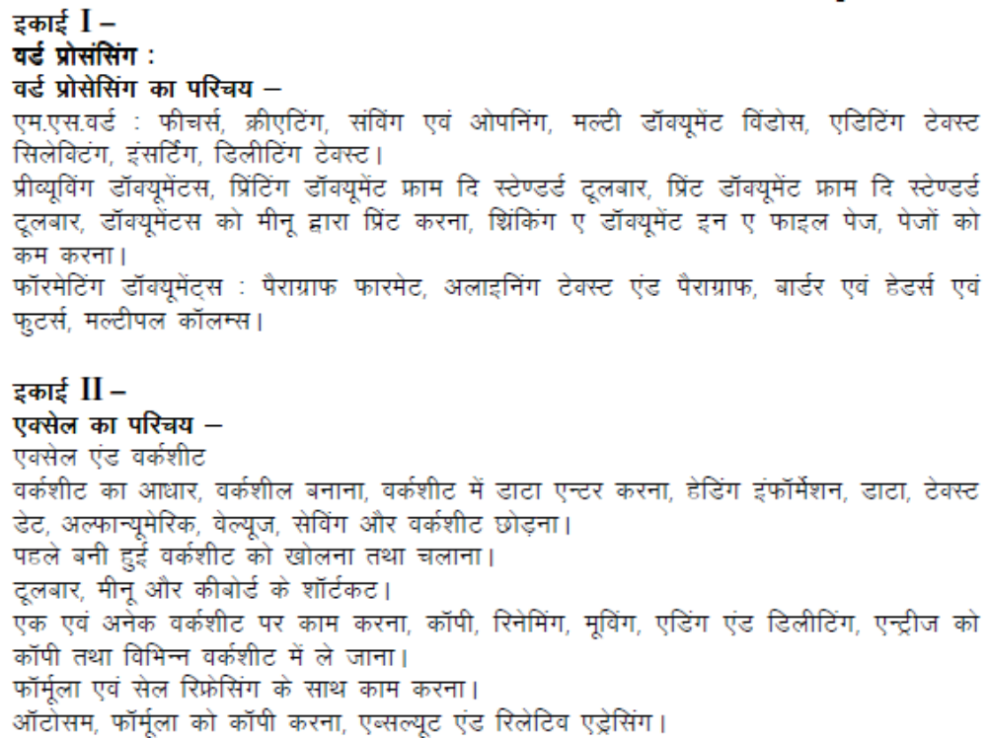

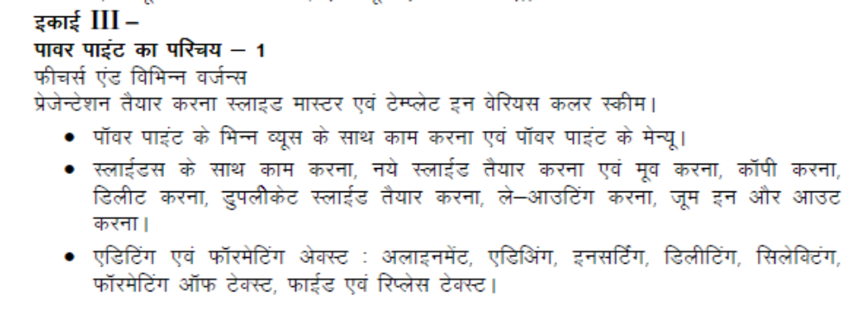

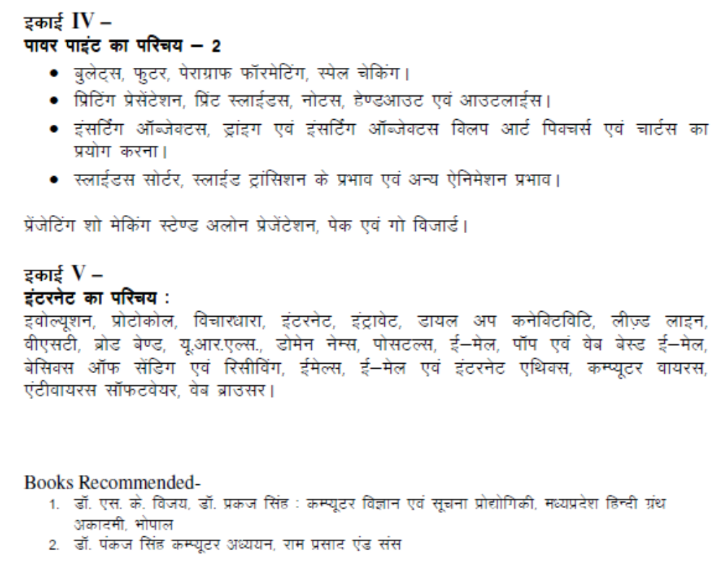

Barkatullah University Bhopal
Semester – Wise Scheme
Session 2013-14 onwards
BCA
Semester VI

Code No. | Paper | Marks (Theory + CCE)
BCA601 | Internet Technology & Security | 85 + 15
BCA602 | Software Engineering | 85 + 15
BCA603 | .Net Technology | 85 + 15
BCA604 | Java | 85 + 15
Practical
BCA605 | Java & .Net | 50
Project (External Assessment) |  | 100

BARKATULLAH UNIVERSITY BHOPAL
SEMESTER – WISE SCHEME FOR BCA
Session 2013-14
Class - BCA
Paper Title - Internet Technology& Security
Paper - I
Semester - VI
Max. Marks : 85
Unit-I Conventional Encryption –Convention Encryption: Conventional Encryption Model, Steganography, Classical Encryption Techniques, Simplified DES, Block Cipher Principles, The data Encryption Standard, The strength of ES, Differential and Linear Cryptanaysis, Block Cipher Design Principles, Block Cipher Modes of Operation, Conventional Encryption algorithms

Unit-II public key encryption and hash functions –public key cryptography, principles of public key cryptosystems, The RSA algorithm, key management, Difie Hellman Key Exchange, Elliptic Curve Cryptography Message Authentication and Hash Functions Authentication Requirements, Authentication Functions, Message Authentication Codes, Hash Functions, Security of Hash Functions

Unit-III Hash And Mac Algorithms MD5 Message Digest Algorithm, Secure Hash Algorithm (SHA-I), RIPEMD, HMAC Digital Signatures and Authentication Protocols

Unit-IV Authentication Applications, IP Security, Web Security

Unit-V Intruders, Veruses and Worms Intruders, Viruses and Related Threats Firewalls Firewall Design Principles, Trusted Systems

BARKATULLAH UNIVERSITY BHOPAL
SEMESTER – WISE SCHEME FOR BCA
Session 2013-14
Class - BCA
Paper Title - Software Engineering
Paper - II
Semester - VI
Max. Marks : 85

Unit-I The Software problem, Software Engineering problem, Software Engineering approach – phased development process, project management and matrices. Software processes–Processes, Projects, Components, Characteristics. Software Development process–process step specification, waterfall model, prototyping, iterative enhancement, spiral model.

Unit-II Software Requirement Analysis and Specification–Software Requirements, Problem Analysis, Requirement Specification, Validation, Metrics.

Unit-III Planning a Software project – Cost Estimation, Project Scheduling, Staffing and personnel planning, Software Configuration management plans, Quality Assurance plans, Project Monitoring Plans, Risk Management.

Unit-IV Software Design– Design Principles, Module level concepts, Design Notation and Specification, Structured Design Methodology, Verification. Coding - Programming Practice, Verification and Metrics.

Unit- V Software Testing–Testing fundamentals, Functional testing, Structural testing, Testing process.
Software Quality Assurance (SQA): Software Reviews, Software Quality factors, SQA activities, Formal Technical Reviews, SQA Approach. Software Configuration Management–Configuration Identification, Change Control, Status Accounting and Auditing.

References:-
Khurana Rohit Software Engineering, IE, Vikas
Pressonan – Software Engg.- MGH

BARKATULLAH UNIVERSITY BHOPAL
SEMESTER – WISE SCHEME FOR BCA
Session 2013-14
Class - BCA
Paper Title - .Net Technology
Paper - III
Semester - VI
Max. Marks : 85
UNIT – I What is .NET, overview of .NET framework and platform, Common Language Runtime, XML as the .NET ”Meta Language”, overview of Visual Studio IDE, New Object capabilities in Visual Basic, Modern Language capabilities added to Visual Basic, fitting Visual Basic into framework.

UNIT-II Overview of ASP.NET framework, Understanding ASP.NET Controls, Applications Web servers, installation of IIS. Web forms, web form controls –server controls, client controls, web forms & HTML, Adding controls to a web form, Buttons, Text Box, Labels, Checkbox, Radio Buttons, List Box, etc. Running a web Application, creating a multiform web project. Form Validation: Client side validation, server Side validation, Validation Controls: Required Field Comparison Range. Calendar control, Ad rotator Control, Internet Explorer Control. State management- View state, Session state, Application state.

UNIT-III Architecture of ADO.NET, Connected and Disconnected Database, Create Connection using ADO.NET Object Model, Connection Class, Command Class, Data Adapter Class, Dataset Class. Display data on data bound Controls and Data Grid. Database Accessing on web applications: Data Binding concept with web, creating data grid, Binding standard web server controls. Display data on web form using Data bound controls.

UNIT-IV Writing datasets to XML, Reading datasets with XML. Web services: Introduction, remote method call using XML, SOAP, web service description language, building & consuming a web service, Web Application deployment.

UNIT-V Overview of C#, C# and .NET, similarities & differences from JAVA, Structure of C# program. Language features: Type system, boxing and unboxing, flow controls, classes, interfaces, Serialization, Delegates, Reflection.

REFERENCES
Pankaj Agrawal – Principal of .Net Framwork – Vaya
Kogent - .NET Programming Black Book – Wiley
VB.NET Black Book by Steven Holzner –Dreamtech
VB.NET –Wrox Publication
ASP.NET Unleashed
C# programming – Wrox Publication
C# programming Black Book by Matt Telles

BARKATULLAH UNIVERSITY BHOPAL
SEMESTER – WISE SCHEME FOR BCA
Session 2013-14
Class - BCA
Paper Title - Java
Paper - IV
Semester - VI
Max. Marks : 85
Unit-I Primitive data type-integer, Short, byte, float, double, Unicode character set, Boolean, their ranges default initial values, wrapping of integer arithmetic, casing comments identifiers and reserved words. Local variables operators, precedence, Examples and Exercises.

Unit-II Statements Simple and compound, Uses of control do, for, while, switch, break case of continue label, class type Data; String, Arrays. Examples and Exercises.

Unit-III Definition and naming conventions for the member of Java classes. Instances, fields and methods initialization by constructors. Creation of Objects, access methods. Example and Exercise.

Unit-IV Inheritance, Super class, Subclass, Method overloading, Interface, Thread, Multithreading example, Synchronized, Exception (Try- Catch-Final blocks examples). Java Virtual Machine concepts, java platform overview, Programming examples to clarify use of objects, threads exception and Packages For I/O, file String handling. Examples and Exercise.

Unit-V Local and Remote Applets Vs Applications, Writing Applets, Applets Life Cycle, Creating an Executable Applet, Designing a Web page, Applet Tag, Adding Applet to HTML file, Running the Applet, Passing Parameters to Applets, Aligning the Display, HTML Tags & Applets, Getting Input from the User.

Reference:-
Schildt java Complete Reference TMH
Das Rashmi kanta Core Java, IE, Vikas
Bansal Nitin, Ajit Kumar,A Simplified approach to Java Programming , KALYANI

